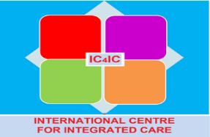
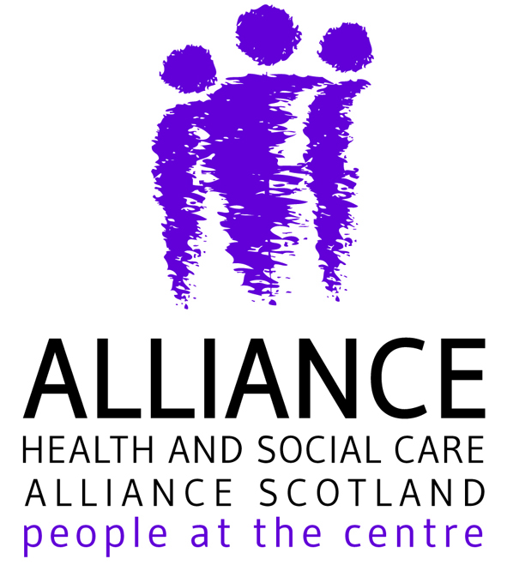

Integrated Care - documents and websites
The International Centre for Integrated Care (IC4IC), hosted by the University of the West of Scotland (UWS), is the home of IFIC Scotland, the Scottish hub for the International Foundation for Integrated Care.
Education and CPD
The University offers a new Masters in Leading People Centred Integrated Care. Some of the modules from this programme will be available for professional development courses. Contact helen.rainey@uws.ac.uk

Webinars
IFIC Scotland, and partners, host Integrated Care Matters webinars featuring health and care practitioners from around the world who generously share evidence, personal insights, practical tips and offer peer support on people-centred integrated care in practice. The webinar recordings and topic materials can be viewed at https://integratedcarefoundation.org/ific-scotland-3

- Series 1 addresses various aspects of integrated care
- Series 2 is focused on active and healthy ageing and frailty, in collaboration with the EU Joint Action on Frailty www.advantageja.eu
Special Interest Groups
IFIC Scotland o coordinates a number of Special Interest Groups:
- Intermediate Care
- Polypharmacy and Adherence
- Palliative and End of Life Care
- Frailty (to commence in the Autumn)
Joining a Special Interest Group (SIG)
To join a SIG please select join IFIC as Community Member, which is free. Once registered you have access to join and get involved in as many SIGs as you wish. You will receive updates of new postings and can participate in discussion forums, blogs and webinars.
Please share your good practices, evaluations or research articles on the SIG topics by emailing Marie at: IFICscotland@integratedcarefoundation.org

Integration and Related Policy
From April 2015, 31 new integration authorities began to make best use of their collective resources to scale up new models of integrated care and support for all adults, particularly the growing numbers of people who have multiple physical and mental health conditions. This is a once in a generation opportunity for a radical shift in the pace and scale of transformational change.
http://www.gov.scot/Topics/Health/Policy/Adult-Health-SocialCare-Integration

Ham C, Heenan D, Longley M and Steel D. 2013. ‘’Integrated care in Northern Ireland, Scotland and Wales. Lessons for England.’’ London: The King’s Fund.
Improving outcomes through transformational health and social care integration: the Scottish Experience – Hendry A, Taylor A, Mercer S and Knight P. Healthcare Quarterly, 19(2) July 2016: 73-79. doi:10.12927/hcq.2016.24703 https://www.longwoods.com/content/24703.
Creating an enabling political environment that supports health and social care integration – Hendry A. International Journal of Integrated Care, 16(4): 7, pp. 1–3, DOI: http://dx.doi.org/10.5334/ijic.2531
Living well in later life in Scotland – Hendry A. Working with Older People, Vol. 21 Iss:1, pp.22 – 30 http://dx.doi.org/10.1108/WWOP-12-2016-0037
Audit Scotland http://www.audit-scotland.gov.uk/report/health-and-social-care-integration
Collaborative leadership development for primary health and social care leaders http://www.nes.scot.nhs.uk/media/3528360/leading_for_integration.pdf
‘Gaun Yersel’ The Self Management Strategy for Long Term Conditions in Scotland
https://www.alliance-scotland.org.uk/wp-content/uploads/2017/11/ALLIANCE-SM-Gaun-Yersel-Strategy-2008.pdf

Self Management campaign: My Condition, My Terms, My Life

Chief Medical Officer for Scotland Annual Report 2015/16 Realising Realistic Medicine
http://www.gov.scot/Resource/0051/00514513.pdf

Making it Easier - a health literacy action plan for Scotland 2017-2025
http://www.gov.scot/Publications/2017/11/3510

Health Literacy Scotland http://www.healthliteracyplace.org.uk/

Primary Care
GP Contract 2018 - http://www.gov.scot/Topics/Health/Services/Primary-Care/GP-Contract
Improving together - A National Framework for Quality and GP Clusters in Scotland
http://www.gov.scot/Resource/0051/00512739.pdf

GP clusters – Scotland – A One Page Guide for GP Practices for 2016/17
http://www.sehd.scot.nhs.uk/pca/PCA2016(M)07.pdf
Scottish School of Primary Care website has briefing papers on GP Clusters and new models of integrated primary care http://www.sspc.ac.uk/.
Each paper summarises research, guidelines and other evidence about areas of care on which GP clusters could usefully focus to improve outcomes
General Practitioners at the Deep End work in 100 general practices serving the most socio-economically deprived populations in Scotland https://www.gla.ac.uk/researchinstitutes/healthwellbeing/research/generalpractice/deepend/

Scotland’s House of Care is a tangible and proven approach to support healthcare staff embrace empower and support people living with multiple long term conditions to articulate their own needs and decide on their own priorities through a process of joint decision making, goal setting and action planning. https://houseofcare.wordpress.com/
https://www.alliance-scotland.org.uk/blog/resources/house-of-care-learning-report/
Many people with long term conditions or chronic health problems can benefit from having a thinking ahead or Anticipatory Care Plan (ACP). If an ACP is developed, a Key Information Summary (KIS) can be completed in the GP electronic record and contain ACP information and wishes. This can be shared with other healthcare settings with the person’s consent so that it can be accessed by acute and emergency care providers and the valuable information used to inform decision making and treatment ceilings. The ACP toolkit and resources including an interactive patient held ACP and ACP app can be accessed at myacp.scot. All Care Homes are receiving the National Anticipatory Care Plan with the expectation that summaries will be uploaded onto KIS by GP practices.
A recent study in BMJ showed that patients with a KIS were less likely to die in hospital than in the community – particularly in end of life care for frailty and dementia. Tapsfield et al BMJ 2016
The National LINKS worker programme LINKS worker blends primary care and community development approaches to primary care. Community Links Practitioners engage the entire team in supporting people to live well in their community through enabling better access to information, knowledge, skills, relationships and community supports. The programme uses asset mapping tools to identify the range of local community supports for health and wellbeing. The Community Links Manager offers direct support to these community resources, aiming to increase their capacity to support people who may seek access to care through their primary care team.
http://www.healthscotland.scot/publications/evaluation-of-the-links-worker-programme-in-deep-end-general-practices-in-glasgow

Coproduction and Personal Outcomes approach to assessment and care planning.

The Personal Outcomes Collaboration website: https://personaloutcomescollaboration.org
Healthcare Improvement Scotland: http://ihub.scot/a-z-programmes/personal-outcomes/
IRISS Conversation Openers: https://www.iriss.org.uk/resources/tools/outcomes-co/
Talking Points – a practical guide http://www.jitscotland.org.uk/resource/talking-points-personal-outcomes-approach-practical-guide/
Scottish Coproduction Network
http://www.coproductionscotland.org.uk/

The power of stories: 100 stories launch
http://www.coproductionscotland.org.uk/events-and-news/news/the-power-of-stories-100-stories-of-co-production-launch/

Scotland National Health and Care Standards are a new single set of standards for health and social care designed around 5 overarching principles: compassion, responsive care and support, wellbeing, be included and dignity and respect. Five standards are supported by 146 outcomes focused statements that will be used in all care home inspections from April 2018. The Standards are based on five headline outcomes:
• I experience high quality care and support that is right for me.
• I am fully involved in all decisions about my care and support.
• I have confidence in the people who support and care for me.
• I have confidence in the organisation providing my care and support.
• I experience a high quality environment if the organisation provides the premises

The Health & Social Care Alliance – Third sector umbrella organisation
https://www.alliance-scotland.org.uk/

Iriss (Institute for Research and Innovation in Social Services) https://www.iriss.org.uk/
ALISS – Social Prescribing Connecting Communities https://beta.aliss.org/
https://www.aliss.org/caboose/resources/1373/
https://www.alliance-scotland.org.uk/blog/opinion/aliss-its-all-about-co-production/

Intermediate Care - Maximising Recovery, Promoting Independence: describes intermediate care as a continuum of integrated community services for assessment, treatment, rehabilitation and support for older people and adults with long term conditions at times of transition in their health and support needs.
http://www.gov.scot/Topics/Health/Support-Social-Care/Independent-Living/Intermediate-Care

Polypharmacy Guidance and tools are available at http://www.polypharmacy.scot.nhs.uk
Polypharmacy reviews can be expected to deliver long-term direct benefits from reduction in the cost and in waste of medicines prescribed, and indirect economic benefits as a patient stabilised on fewer medicines will require less contact with health professionals and fewer unscheduled hospital admissions due to adverse drug reactions. economic analysis Scotland

Networks
Effective networks for improvement Developing and managing effective networks to support quality improvement in healthcare
https://www.health.org.uk/sites/health/files/EffectiveNetworksForImprovement.pdf
Source for Networks website contains various resources – free to register
http://www.source4networks.org.uk/

Prof Anne Hendry
Clinical Lead for Integrated Care
Work Package Leader ADVANTAGE JA
Senior Associate, International Foundation for Integrated Care (IFIC)
Email: anne.hendry@lanarkshire.scot.nhs.uk

Mandy Andrew
Senior Programme Manager
NHS Lanarkshire - ADVANTAGE JA
E: mandy.andrew@lanarkshire.scot.nhs.uk

