My health for life is a free behaviour change program designed for Queenslanders at high risk of developing a chronic condition and shows participants that making small lifestyle changes can have major health benefits.
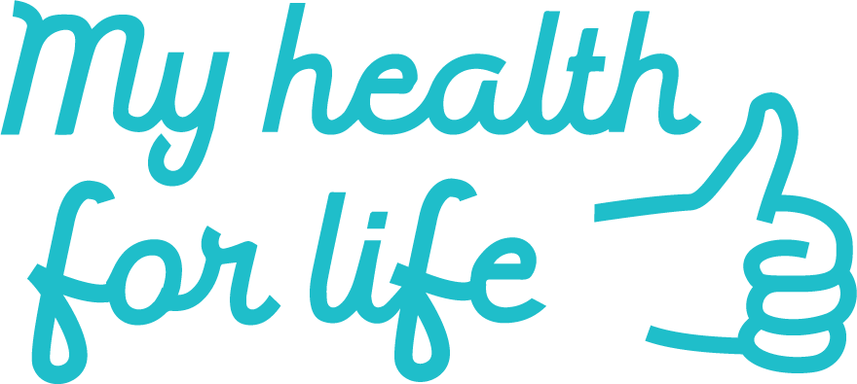

The program works in partnership with general practice and is a practical extension of the advice given by GPs and nurses to their patients.
Participants can choose to complete the program via face-to-face,
video conferencing or telephone coaching.
Note: Participants can attend a VC session with a facilitator
anywhere in Queensland.
Our team will assist participants in selecting a program mode,
timeslot and location that suits their needs.
Patients can be referred using the practice software My health for life referral template
or calling 13 74 75.

Date | Time | Provider | Facilitator | Suburb
Tuesday 1st November | 5:30pm | My Nutrition Clinic | Molly Warner | Virtual sessions
Tuesday 1st November | 11:30am | Prime Physiotherapy | Babita Gehlawat | Virtual sessions
Monday 7th November | 4:00pm | Griffith Uni Health Clinic | Nick Steel | Virtual sessions
Wednesday 9th November | 5:30pm | Happier, Healthier | Brianna James | Gladstone
Wednesday 9th November | 6:00pm | True North Wellness | Vicky Graham | Virtual sessions
Thursday 12th January 2023 | 6:30pm | My nutrition Clinic | Molly Warner | Virtual sessions

For more information, visit myhealthforlife.com.au
Your local PHN can work with your practice to identify patients who are eligible for referral into the program. If you would like more information on how to get involved, please contact your area manager.

